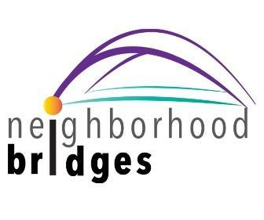

Dear Families:

We wanted to take a moment so that you are all aware of an amazing charity and resource that serves our most at-risk students and families in our community. neighborhood bridges Tarrant is a 501(c)(3) charity that is volunteer driven here in Tarrant City Schools and promises to be so impactful for our students in need.  Watch this [brief video](https://www.youtube.com/watch?v=mNBXbv_I8Ws&feature=youtu.be) for an overview on how our “Gateway for Kindness” works.

neighborhood bridges’ mission is: To bridge communities with schools in providing basic needs, and removing barriers for students so they can engage and succeed in school and life. E

neighborhood bridges partners with our counselors, social workers and school administrators who have login access to our platform to post needs on behalf of students and families (who remain anonymous). Needs encompass a wide range of essentials, including school supplies, coats and clothing, personal care items, help with school or athletic fees, household needs such as beds or groceries, and much more.

Once an advocate posts a need, it is circulated among subscribers (or donors) in the community via a daily email and social media posts. A subscriber wishing to fill a need simply clicks “I can help.” They are then provided with drop-off instructions for the donor and then our team of Area Directors will pick-up the donation and deliver it to the recipient.

Here’s how you can participate:

1. Subscribe to neighborhood bridges Community by clicking here: [**nbTarrant**](https://neighborhoodbridges.org/community/tarrant-al)
2. Follow neighborhood bridges on social media by clicking any of these social media channels

[**Facebook**](https://www.facebook.com/profile.php?id=61575164938797)

[**Instagram**](https://www.instagram.com/nb.tarrant/)

1. Volunteer if you would like to help neighborhood bridges (community name) serve our students and families.  [Click HERE to volunteer!](https://forms.gle/XuiP6KkLjkB3NUJC7)

 If your student/family is in need of essentials and assistance from neighborhood bridges - Community Name, please contact a school counselor or social worker to get started.

Should you have questions, or want more information on the organization, email us at:

[tarrant@neighborhoodbridges.org](mailto:tarrant@neighborhoodbridges.org)

neighborhood bridges Tarrant gives our team an invaluable resource to help meet students’ basic needs and support local families. We encourage you to subscribe to neighborhood bridges, and to reach out if this organization may be of service.

Sincerely,

Tarrant City Schools